Spring
Seminar


April 6, 2024
Please Pre-Register by:
- Calling 519 887 9658
- Texting 519 569 9241
- Email peacefulheartministries@gmail.com

If you do not pre-register you are still welcome to come

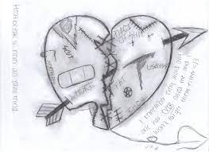
Abuse

Bring Your Lunch

Topic: Abuse
Hope for the Perpetrator & the Abused
9:15 Registration
9:45 Welcome
10:00 Topic: What Is Abuse? - Dave Lichty
11:40 Testimony
12:00 Lunch (bring your lunch)
Special singing begins at 12:45
1:00 Topic: God’s Heart for the Perpetrator-
Hope & Restoration – Abe Klassen
1:50 Small Group
2:20 Break
2:35 Topic: God’s Heart for the Abused –
. Hope & Healing – Dave Lichty
3:25 Small Group
3:55 Special Singing
4:00 Announcements and Dismissal

Hope for the Perpetrator & the Abused

Where: Leamington Lebanese Club
447 Hwy 77 Staples (Leamington) ON

Prov. 31: 8 -9 (AMP)
⁸ Open your mouth for the dumb [those unable to speak for themselves], for the rights of all who are left desolate and defenseless; ⁹ Open your mouth, judge righteously, and administer justice for the poor and needy.

